MEDIDATA INVITATIONS
You will receive an invitation from Medidata (iMedidata-Notifcation@mdsol.com). If this is your first time setting up an iMedidata account, then you will be required to set-up your profile. For example, name, address, title, etc.

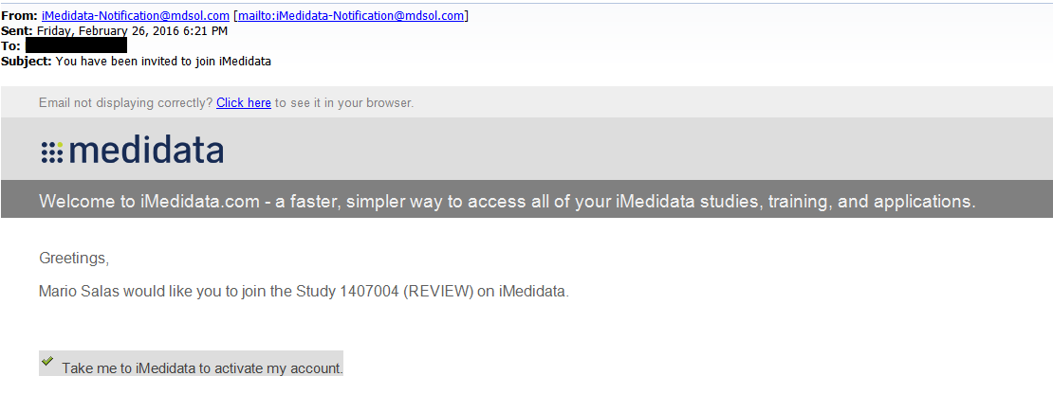

If you are being invited to a study after you have set-up your account, you will receive an email inviting you to that study. NOTE!: Please be aware that these emails sometimes go to JUNK MAIL.

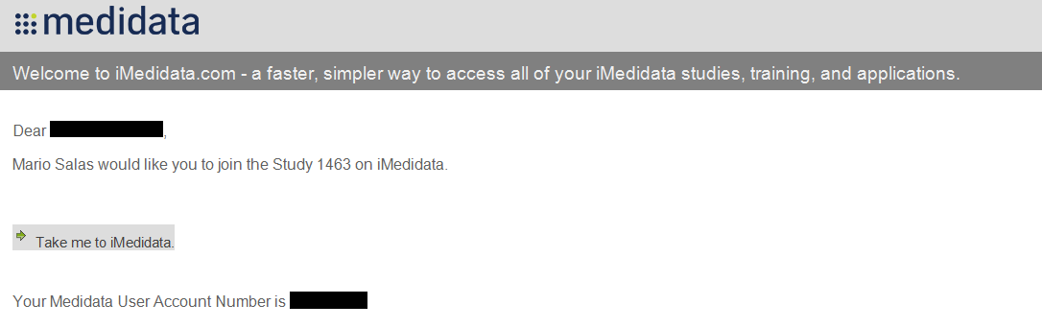

When you navigate to iMedidata and log into the system, you will see the studies you are invited to in the upper right hand corner.

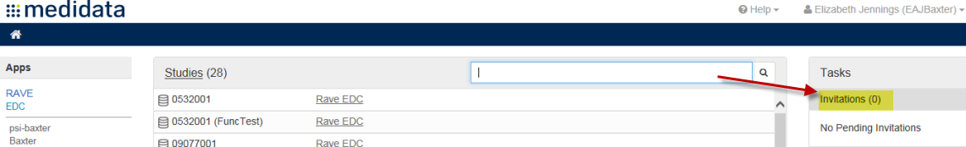

eLEARNINGS
You will have eLearnings assigned to you depending on your user roles. It is a requirement to take eLearnings because we need to have evidence that you are trained before working in Electronic Data Capture (EDC).
- Once you have taken eLearnings in a certain user role, you can be added to other studies with that user role without having to re-take the exams.
- If you have any issues with the eLearning assignments, please do not hesitate to contact the study Clinical Data Manager (CDM).

User Role | Application | eLearnings
Site Clinical Research Coordinator (CRC) | Rave EDC | Rave EDC Essentials for Clinical Research Coordinators
Site Investigator | Rave EDC | Rave EDC Essentials for Investigators with Data Entry

UPDATING USER ADMINISTRATION
If you need to add or change site users, please reach out to your study CDM. You must complete the Account Access Form and highlight the changes requested.

MEDIDATA HELP DESK
Sometimes issues can be resolved by reaching out to Medidata.
